## UML Diagrams

### UML Use Case Diagram

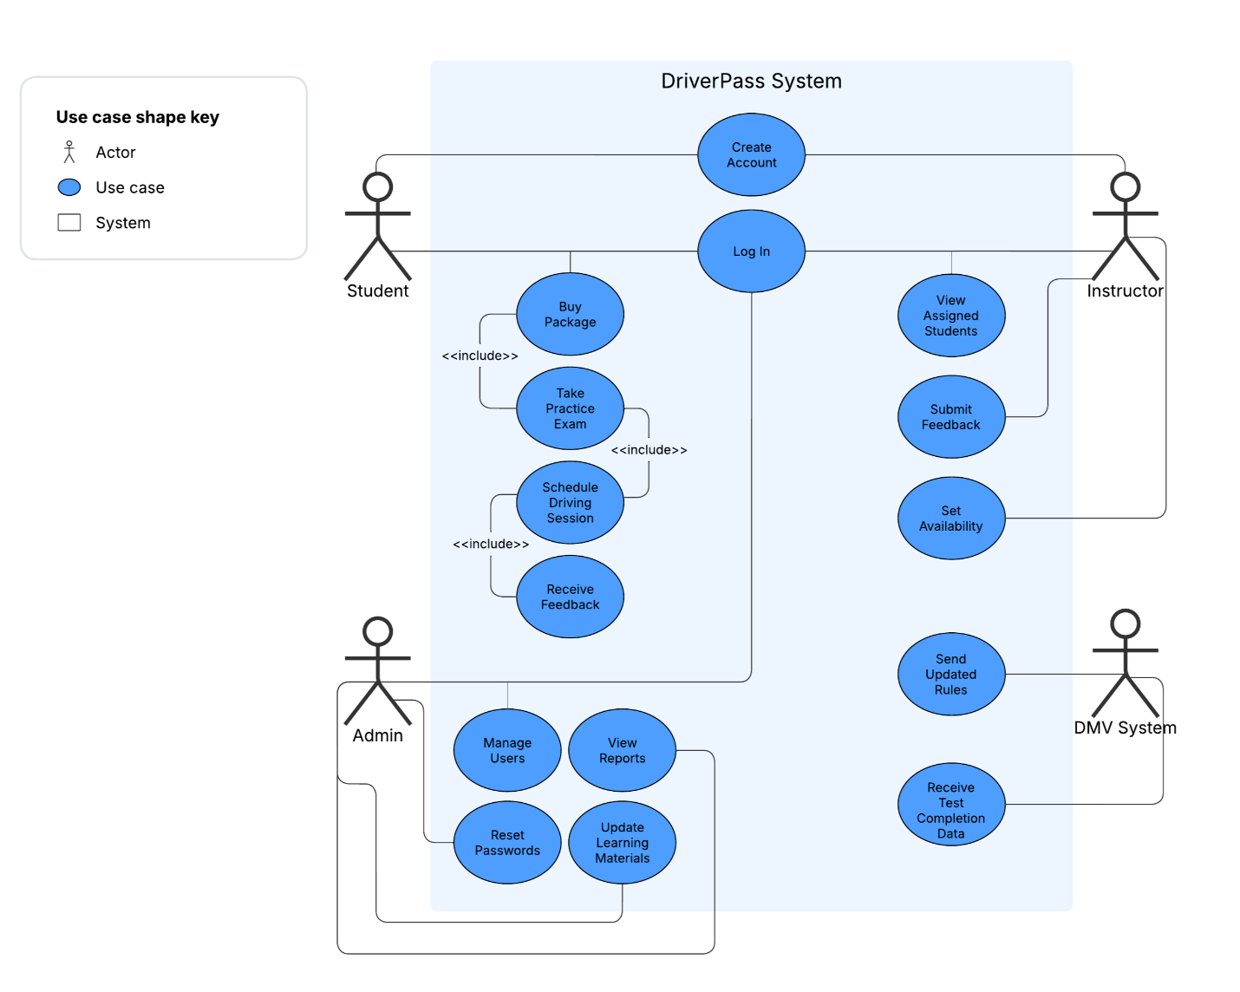

### UML Activity Diagrams

### UML Sequence Diagram

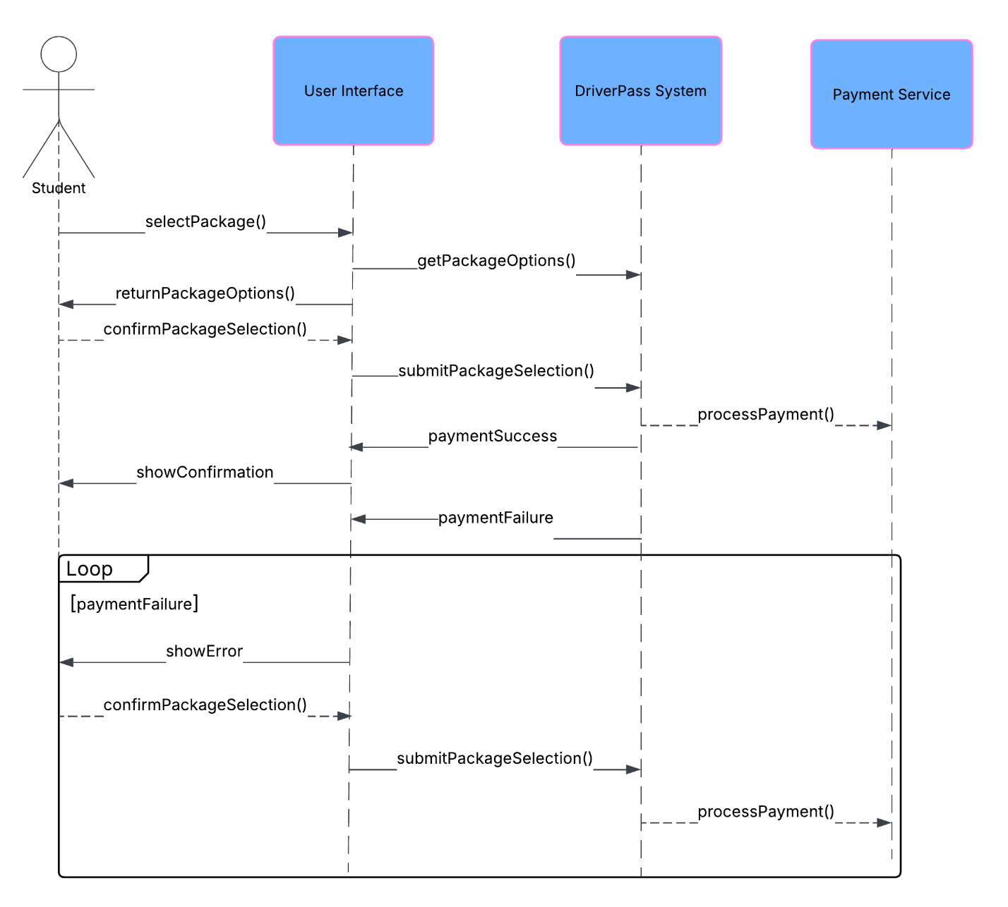

### UML Class Diagram

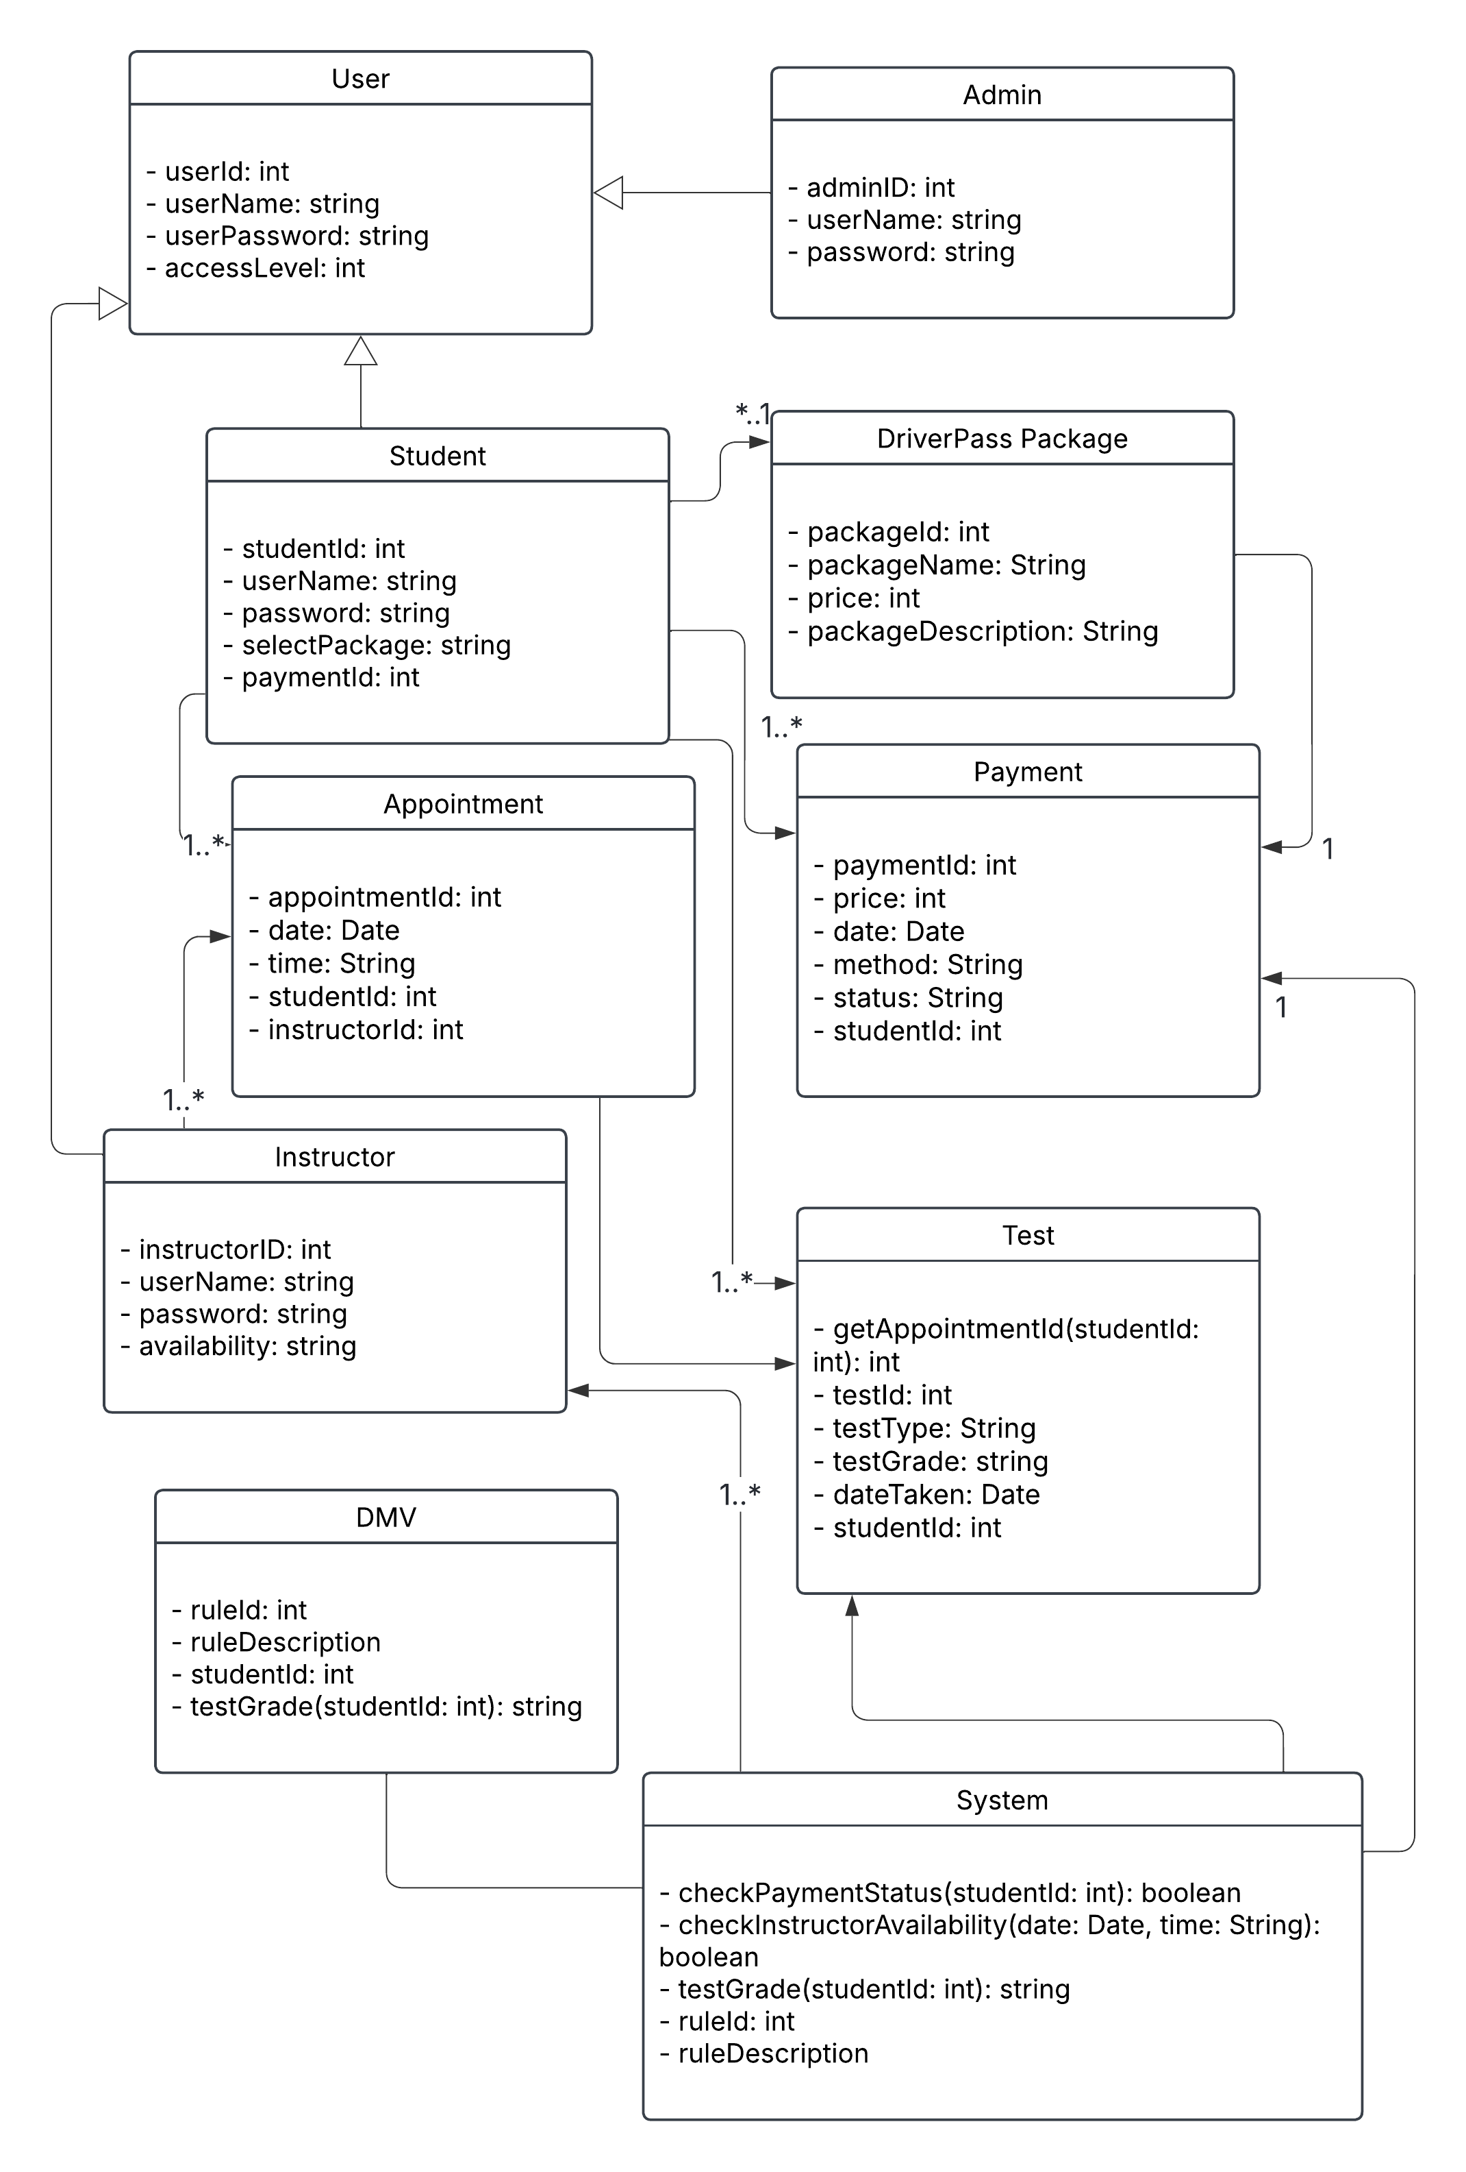

## Technical Requirements

The DriverPass system will require the following technical setup:

* **Hardware:**
  + Cloud-based server hosting for scalable access (ex. AWS or Azure)
  + Web-enabled devices for users (students and instructors), such as smartphones, tablets or PCs
* **Software:**
  + Web application developed with a full-stack framework (ex. MERN or Django)
  + Database (ex. MySQL or MongoDB) for storing user data, appointments and packages
  + Front-end: HTML/CSS/JavaScript with support for mobile browsers
* **Tools:**
  + Lucidchart for design modeling
  + IDE for development (ex. Visual Studio Code)
* **Infrastructure:**
  + HTTPS for secure data exchange
  + Role-based authentication and access control
  + Integration API for DMV system to send/receive test data
  + Secure login and brute-force protection for user accounts
  + Regular backups and monitoring for system uptime and data safety